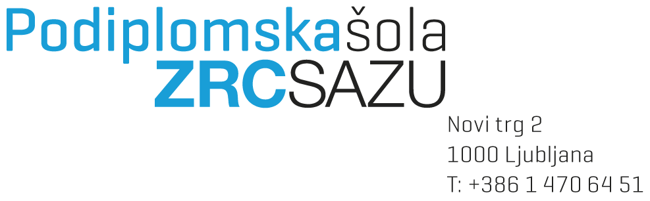

DOCTORAL THESIS PROPOSAL FORM

Enrolment number:

Student’s name and surname:

Date and place of birth:

Previous education:

Permanent residence

Street number and street:

Postal code, post, county:

Other address (for post):

Street number and street:

Postal code, post, county:

Telephone number:

E-mail:

Doctoral study (3rd level) programme:

Module:

Doctoral thesis proposal title (in Slovene and English language):

Slovene:

English:

Place and date:

Student's signature: __________________________________________

|  |  |
| --- | --- |
| Mentor's agreement: | If co-mentor, co-mentor's agreement: |
| Name and surname: | Name and surname: |
| Title: | Title: |
|  |  |
| Signature: | Signature: |
|  |  |
| If co-mentor, co-mentor's agreement: | If co-mentor, co-mentor's agreement: |
| Name and surname: | Name and surname: |
| Title: | Title: |
|  |  |
| Signature: | Signature: |

Attachments in the following order (as specified in Articles 40b and 41 of the Rules on Study Programs of the 2nd and 3rd Cycle) – mark:

Application, where candidate:

* Applies for the acceptance of the doctoral dissertation topic;
* Proposes the field (study program) in which they wish to obtain the doctoral degree;
* Proposes a mentor, with or without a co-mentor(s), for the doctoral dissertation;
* Submits 3–5 references of the mentor and any potential co-mentor(s) in the field of the doctoral dissertation topic within the last 5 years;
* May request to write in another foreign language recognized in the field.

Candidate's curriculum vitae with a focus on their work in the scientific field (professional CV);

List of published scientific and other professional works (bibliography);

Dissertation proposal in the format defined in Article 41b of these rules:

* Title of the dissertation in Slovenian, English, or another foreign language recognized in the field;
* Justification of the scientific relevance of the research issue based on the study of relevant literature;
* A research question, thesis, or hypothesis derived from or justified by the research issue;
* Description and justification of the research methodology, research methods, and the structure of the dissertation;
* An answer to the question of what the original contribution of the dissertation to the development of the scientific discipline will be;
* A brief structure of the dissertation (in the form of a table of contents);
* A list of key sources on which the dissertation will rely and those already referenced in the proposal.

The proposal must be written and formatted according to the Guidelines for Formatting Scientific and Professional Texts at the Postgraduate School ZRC SAZU and must comprise 10 to 15 pages (excluding the bibliography and the structure of the dissertation in the form of a table of contents).

An implementation plan corresponding to the dissertation proposal, which realistically defines the timeframe for researching and writing the doctoral dissertation.

The Study Office attaches:

The minutes of the successful presentation of the doctoral dissertation topic;

A summary of the presentation of the doctoral dissertation topic.

TO BE COMPLETED BY THE STUDY OFFICE

The application for the doctoral dissertation topic contains all the required documentation:

Yes  / No

Deadline for completion:

The date of acceptance of the application:

Signature: _______________________________