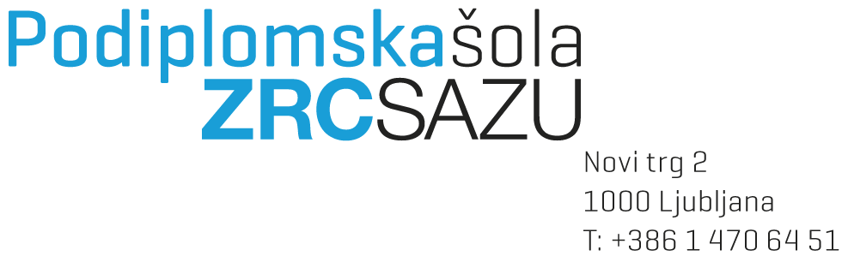
DOCTORAL THESIS PROPOSAL FORM

Enrolment number:
Student’s name(s) and surname(s):
Date and place of birth:
Date and title of obtained education:

Permanent residence
Street and house number:
Postal code, city and county:

Address for correspondence:
Street and house number:
Postal code, city and county:

Telephone number:
E-mail address:

Third-cycle doctoral study programme:
Study module:

Doctoral thesis title:
Title in Slovenian:
Title in English:

Place and date:
Student's signature: _______________________

Consent of the proposed (co-)supervisor(s) and the module coordinator is given by signature:

Mentor's agreement: | If co-mentor, co-mentor's agreement:
Name(s) and surname(s): | Name(s) and surname(s):
Academic title: | Academic or research title:
Signature: | Signature:
If co-mentor, co-mentor's agreement: | If co-mentor, co-mentor's agreement:
Name(s) and surname(s): | Name(s) and surname(s):
Academic or research title: | Title:
Signature: | Signature:
Mandatory attachments as defined in Article 40.b and 41.b of the Rules on Study Programmes of the 2nd and 3rd Cycle – to be marked by the student:
1. Application in which the candidate:
- requests approval of the proposed doctoral dissertation topic,
- proposes the field (study program) in which they wish to obtain the doctoral degree,
- proposes a supervisor and any co-supervisor(s),
- submits 3–5 references of the supervisor and any co-supervisor(s) related to the dissertation topic from the last 5 years,
- may request to write in foreign language established in the discipline.
2. Candidate’s CV with emphasis on their work in the scientific field (professional CV);
3. List of any published scientific and other professional works (bibliography);
4. Doctoral dissertation proposal (disposition) in the form defined in Article 41.b of the Rules:
- Title of the dissertation in Slovenian, English, or another foreign language recognized in the field;
- title in Slovenian and in English or another foreign language established in the discipline;
- scientifically justified relevance of the research problem based on the study of relevant literature;
- research questions derived from or justified by the research problem and clearly stated objectives, theses, or hypotheses;
- description and justification of the research methodology and structure of the dissertation;
- explanation of the original contribution of the dissertation to the development of the scientific discipline;
- brief structure of the dissertation (table of contents format);
- list of key sources on which the dissertation will be based and which are already used in the proposal.
The proposal must be written and formatted in accordance with the Guidelines for Editing Scientific and Professional Texts at PŠ ZRC SAZU. The expected length is between 8 and 15 pages (approximately 1,800 characters with spaces per page), excluding references and the table of contents.
Implementation plan corresponding to the dissertation proposal, clearly defining the timeline for research and writing.

To be attached and marked by the Student Affairs Office:
Record of the successful presentation of the doctoral dissertation topic;
Summary of the presentation of the doctoral dissertation topic.

TO BE COMPLETED BY THE SSTUDENT AFFAIRS OFFICE
The application for the doctoral dissertation topic contains all required documentation:
Yes / No
Deadline for completion:

Date of application receipt:

Signature: _______________________________

